
Smart Delivery Route System
By
Tejas thakor
Milestone 2

Executive Summary
The SmartDeliveryRoute system is a specialized logistics and transportation management solution designed to optimize delivery operations. This project aims to streamline the process of route planning, real-time telemetry tracking, and user management for delivery fleets.
This report details the backend architecture, API development, and database implementation of the system. The core focus of this phase was to build a robust, scalable, and secure backend using Java
PROJECT OBJECTIVES
The primary objectives of the SmartDeliveryRoute backend were:
- To design a layered architecture that separates concerns between data access, business logic, and API control.
- To implement a NoSQL database (MongoDB) capable of handling flexible schemas for route plans and high-volume telemetry data.
- To expose secure and efficient RESTful APIs for frontend applications (web or mobile) to consume.
- To manage geospatial data (GeoPoint) effectively for accurate tracking and routing
- Spring Boot and MongoDB to handle complex geospatial data and high-frequency telemetry updates

Technical Stack
- Language: Java
- Framework: Spring Boot (providing Dependency Injection, MVC structure, and ease of configuration)
- Database: MongoDB (NoSQL database chosen for its performance with JSON-like documents and geospatial querying capabilities)
- Build Tool: Maven (implied by the .mvn folder and standard structure)
- Architecture Pattern: Controller-Service-Repository (Layered Architecture)

API DEvelopment
I was responsible for designing and implementing the REST API endpoints that serve as the bridge between the client-side application and the server. This involved:
- Defining HTTP methods (GET, POST, PUT, DELETE) for resource management.

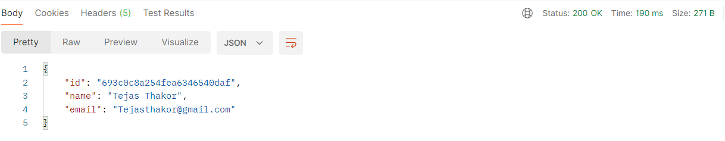
- Ensuring proper response structures and error handling.
- Implementing the Controller Layer to handle incoming web requests.
Database Design & Management
I designed the MongoDB schema to ensure efficient data storage and retrieval. Given the nature of a delivery system, I chose MongoDB for its ability to handle nested objects (like coordinates in a route) and rapid write operations required for telemetry.
- Created collections for Users, RoutePlans, and Telemetry.
- Implemented the Repository Layer to abstract database interactions.

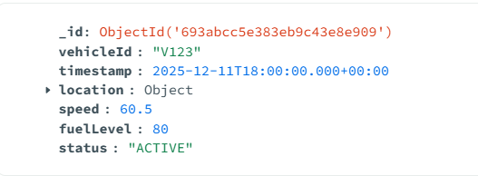 | 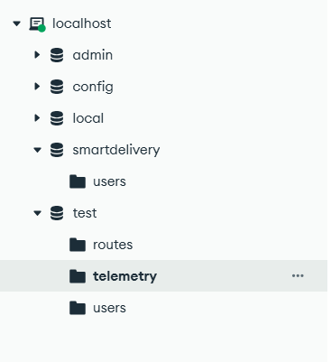
Database Structure and data in it

Business Logic Implementation
I developed the Service Layer to encapsulate the core logic of the application, ensuring that controllers remain lightweight and the code remains testable and modular

sYSTEM aRCHITECTURE AND COMPONENT BREAKDOWN
The project follows a standard industry-grade Layered Architecture. Below is a detailed breakdown of the components I created, based on the project file structure.
The Model Layer (Data Entities)
This layer defines the structure of the data stored in MongoDB.
- User: Represents the actors in the system (e.g., Drivers, Fleet Managers, Admins). It likely contains fields for authentication credentials, names, and roles.

- RoutePlan: This is a core entity that defines a delivery mission. It contains data regarding the start point, end point, stops, and assigned driver.
- Telemetry: Designed to handle high-frequency data streams. This model captures real-time status updates from delivery vehicles, such as current speed, timestamp, and battery/fuel levels.
- GeoPoint: A custom utility model embedded within RoutePlan and Telemetry to store geospatial coordinates (Latitude and Longitude), allowing for location-based calculations.
The Repository Layer (Data Access)
I utilized Spring Data MongoDB to create interfaces that handle data operations without boilerplate code.
- UserRepository: Handles database operations for user management (e.g., findByUsername, save).
- RoutePlanRepository: Manages the retrieval and storage of delivery routes.
- TelemetryRepository: Handles the ingestion of real-time tracking logs.
The Service Layer (Business Logic)
This layer acts as the brain of the application, processing data before it is saved or sent to the user.
- UserService: Contains logic for user registration and profile management.
- RoutePlanService: Implements algorithms or logic to validate routes, assign routes to drivers, and calculate estimated delivery times.
- TelemetryService: Processes incoming telemetry streams. It might include logic to detect anomalies (e.g., if a driver goes off-route) before saving the data.
The Controller Layer (REST APIs)
This layer handles incoming HTTP requests and maps them to the appropriate service methods.
- UserController: Exposes endpoints such as /api/users/register or /api/users/login.
- RoutePlanController: Provides endpoints for managers to create routes (POST /api/routes) and for drivers to fetch their assigned paths (GET /api/routes/{id}).
- TelemetryController: A high-throughput endpoint (likely POST /api/telemetry) used by the driver's device to push location updates periodically

Key Features Implemented
- Dynamic Route Management: The system allows for the creation and modification of complex delivery routes stored as JSON documents in MongoDB.
- Real-time Data Handling: The Telemetry module is architected to accept frequent updates from delivery vehicles, enabling real-time tracking features on the frontend.
- Scalable Data Structure: By using GeoPoint as a modular component, we ensure that location data is standardized across different modules (both in planning and tracking)

KEY FEATURES IMPLEMENTED

Key Features Implemented
- Dynamic Route Management: The system allows for the creation and modification of complex delivery routes stored as JSON documents in MongoDB.
- Real-time Data Handling: The Telemetry module is architected to accept frequent updates from delivery vehicles, enabling real-time tracking features on the frontend.
- Scalable Data Structure: By using GeoPoint as a modular component, we ensure that location data is standardized across different modules (both in planning and tracking)
cONCLUSION
The backend for SmartDeliveryRoute has been successfully architected to support a modern delivery tracking application. By leveraging the flexibility of MongoDB and the robustness of Spring Boot, we have created a system that is both scalable and maintainable. The separation of concerns through the Controller-Service-Repository pattern ensures that future features, such as route optimization algorithms or notification services, can be added with minimal friction

